**Assignment Interview question**

**Name: Swapnali Thakur**

**Email: swapnalithakur217@gmail.com**

Note :- Please prepare the answer of these questions in brief :- (in your own words)

1. **What is the need of IAM?**

* **IAM helps to administrator to define who can access what in AWS account.**
* **Its allow you to assign permission to group of user or specific one.**
* **Access auditing using AWS CloudTrail**

1. **If i am a non tech person, how will you define policies in IAM.**

**ANS:**

* **Search for IAM service in AWS dashboard**
* **Navigate to left side and click on policies**
* **Click on create policy blue button on top right.**
* **You will enter in visual editor tab.**
* **Here you can select service. I’m selecting EC2**
* **Select checkbox for Manual actions and** Access level
* Select resources. I’m selecting all resources
* Select request condition. I’m selecting MFA required.
* Click on next -> add tag is optional -> click on next
* Add name to your policy. Eg. Test-IAM-Policy
* Add description check summary and click on create policy button on bottom right.

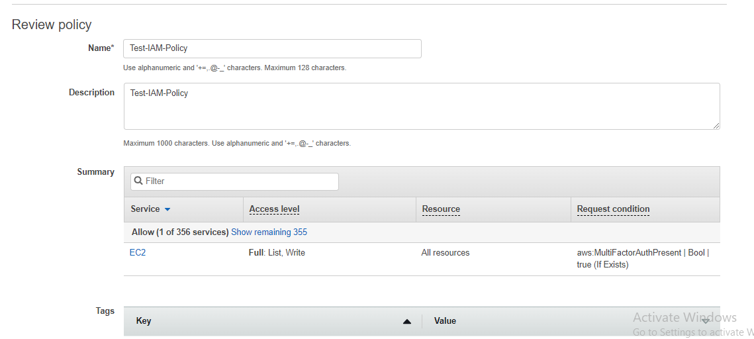

1. **Please define a scenerio in which you would like to create your on own IAM policy.**

**ANS:**

create an identity-based policy that allows full RDS database access within a specific Region.

**4. Why do we prefer not using root account?**

* Because root is the super user. As root you can do anything, as such it is easy for you or someone to kill your system.
* if you make a small mistake as a non-root user, there won't be any extremely fatal outcomes like: deleted /move of binaries or deletion of special folders
* Whilst you can make the mistakes with sudo, often you will think twice before issuing a command as you need to enter your password.
* if you type the wrong thing in as root, it can have disastrous consequences.

1. **How to revoke policy for an IAM user?**

* **Search for IAM service in AWS dashboard**
* **Navigate to left side and click on users**
* **Click on particular user from the list of users**
* **You will able to see list of policies assign to that user click on cross sign or delete sign**
* **Then it will prompt for detaching policy.**
* 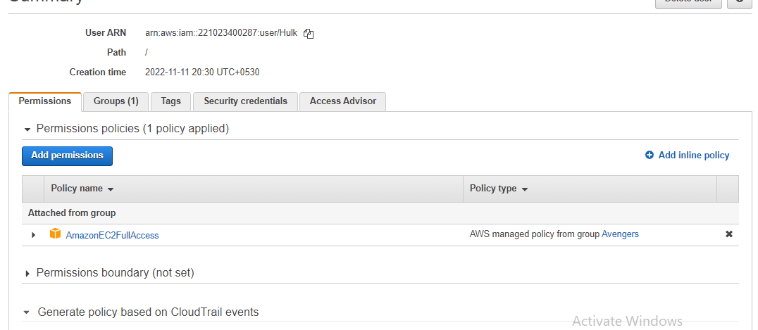

**6. Can a single IAM user be a part of multiple policy via group and root? how?**

Yes. A user can be part of multiple policies via group. We can create multiple group and assign polices to them and one user can be part of multiple group so the single user can be part of multiple policies.